



Statistical Computing

and

Simulation HW3

授課教授: 余清祥教授

學生: 統計碩一 106354003 林健宏

統計碩一 106354012 曹立諭

**目錄**

# Question 01. 2

# Question 02. 3

# Question 03. 4

# Question 04. 5

# Question 05. 6

❒ 附錄 (R code) 7

1. 7

2. 8

3. 9

4. 10

5. 11



Experiment with as many variance reduction techniques as you can think of to apply the problem of evaluating $P\left(X>1\right)for X∼Cauchy$.

實際 $θ≈$*P*( *X* > 1) = 0.25

以Monte-Carlo Integration為基準，並使用其他變異數縮減方法去降低估計的誤差，使用方法有以下幾種：Hit or miss、Antithetic Variate、Importance Sampling、Control variate以及Stratified Sampling

（其中用於Control variate的另一函數為 $\frac{1}{1+x}$, x = 0 ~ 1，Stratified Sampling將定義域分為5層並平均分配抽樣數，用於Importance Sampling的另一函數為 $\frac{1}{x^{2}} , x=0\sim 1$。）

每一個方法皆取1000個隨機樣本生成一個 $\hat{θ}$，再生成1000樣本 $\hat{θ}$，並運用其平均去估計真實的 $θ$ 及計算樣本變異數。

在此以表格方式呈現

|  |  |  |  |  |  |  |
| --- | --- | --- | --- | --- | --- | --- |
|  | MonteCarlo | Hit or miss | Antithetic | Importance | Control | Stratified(5) |
| $$E(\hat{θ})$$ | 0.24997910 | 0.2498500 | 0.24999466 | 0.24997706 | 0.25017903 | 0.25001367 |
| $$var(\hat{θ})$$ | 0.00000272 | 0.0001932 | 0.00000004 | 0.00000244 | 0.00000983 | 0.00000009 |

另外亦有探討抽樣樣本數的問題，分別取100、1000、10000樣本數，去探討樣本平均以及樣本變異數之間的關係。

在此以表格方式呈現

|  |  |  |  |  |  |  |
| --- | --- | --- | --- | --- | --- | --- |
| n = 100 | Monte-Carlo | Hit or miss | Antithetic | Importance | Control | Stratified(5) |
| $$E(\hat{θ})$$ | 0.25028315 | 0.24937000 | 0.25002894 | 0.24989915 | 0.24878815 | 0.2500383 |
| $$var(\hat{θ})$$ | 0.00002736 | 0.00185055 | 0.00000041 | 0.00002551 | 0.00009001 | 0.0000008 |

|  |  |  |  |  |  |  |
| --- | --- | --- | --- | --- | --- | --- |
| n = 1000 | Monte-Carlo | Hit or miss | Antithetic | Importance | Control | Stratified(5) |
| $$E(\hat{θ})$$ | 0.24997910 | 0.2498500 | 0.24999466 | 0.24997706 | 0.25017903 | 0.25001367 |
| $$var(\hat{θ})$$ | 0.00000272 | 0.0001932 | 0.00000004 | 0.00000244 | 0.00000983 | 0.00000009 |

|  |  |  |  |  |  |  |
| --- | --- | --- | --- | --- | --- | --- |
| n = 10000 | Monte-Carlo | Hit or miss | Antithetic | Importance | Control | Stratified(5) |
| $$E(\hat{θ})$$ | 0.25001537 | 0.24978600 | 0.2499985 | 0.24997728 | 0.25001918 | 0.25000063 |
| $$var(\hat{θ})$$ | 0.00000025 | 0.00001847 | 0.0000001 | 0.00000024 | 0.00000099 | 0.00000001 |

結論：

實際 $θ=$ P( X > 1) = 0.25，由上表可知，每個方法都估計的數值相差無幾，只有Antithetic Variate與Stratified Sampling的樣本變異數來得非常小，而Control variate與Hit or miss來得相對大滿多，其中Control variate可能與取得函數有關，若是能取得更適合的函數，也許可以將樣本變異數降低更多。

而抽樣樣本數也是一個問題，當樣本數由小至大會發現樣本數的樣本變異數會下降很快，會近乎接近0。因此，在本題使用的估計方法以Antithetic Variate與Stratified Sampling為優，樣本數則是越多誤差越小。



Hammersley and Handscomb (1964) used the integration of $ $θ=\int_{0}^{1}{\frac{e^{x}-1}{e-1}}dx on (0,1)$

as a test problem of variance reduction techniques (which is about 0.4180233).

Achieve as large a variance reduction as you can. (They achieved 4 million.)

實際 θ = $\int_{0}^{1}{\frac{e^{x}-1}{e-1}}dx$ $≈$ 0.4180233

以Monte-Carlo Integration為基準，並使用其他變異數縮減方法去降低估計的誤差，使用方法有以下幾種： Antithetic Variate、Importance Sampling、Control variate以及Stratified Sampling

（其中用於Control variate的另一函數為 $e^{x}-1$, x = 0 ~ 1，Stratified Sampling將定義域分為5層並平均分配抽樣數，用於Importance Sampling的另一函數為 $q\left(x\right)=\frac{4}{π\left(1+x^{2}\right)}, 0<x<1$。）

每一個方法皆取1000個隨機樣本生成一個 $\hat{θ}$，再生成1000樣本 $\hat{θ}$，並運用其平均去估計真實的 $θ$ 及計算樣本變異數。

|  |  |  |  |  |  |
| --- | --- | --- | --- | --- | --- |
|  | Monte-Carlo | Antithetic | Importance | Control | Stratified(5) |
| $$E(\hat{θ})$$ | 0.41787975 | 0.41805356 | 0.41824956 | 0.4180233 | 0.41804309 |
| $$var(\hat{θ})$$ | 0.00008453 | 0.00000281 | 0.00015477 | 9.253717e-36 | 0.00000345 |

結論：

實際 θ = $\int_{0}^{1}{\frac{e^{x}-1}{e-1}}dx$ $≈$ 0.4180233，由上表可知，每個方法都估計的數值相差無幾，其中Control variate的樣本變異數相對於其他的方法來得小很多，近乎接近0。

而Importance Sampling的樣本變異數則是相對於其他方法來得大，這可能與選取的函數有關（本題使用 $q\left(x\right)=\frac{4}{π\left(1+x^{2}\right)}, 0<x<1$），若是能取得更適合的函數，這樣或許可以將樣本變異數降下來。因此，在本題中所使用的估計方法以Control variate為優，而樣本數與第一題一樣，取樣的樣本數越多，則樣本變異數會越小。



Let $X_{i},i=1,2,3,4,5$ be independent exponential random variables each with mean 1,

and consider the quantity $\theta$ defined by $θ=P(\sum_{i=1}^{5}{iX_{i}}≥21.6)$.

Propose at least three simulation methods to estimate $\theta$ and compare their variances.



First, simulate 100 observations from $Beta(2,3)$ and then use 3 density estimating methods to smooth the observations. You need to specify the parameters in the smoothing methods, and compare the results.



Let $x$ be 100 equally spaced points on $[0,2π]$ and let $y_{i}={sinx}_{i}+ϵ_{i}$ with $ϵ_{i}∼N(0,0.09)$.

Apply at least 3 linear smoothers and compare the differences, with respect to mean squares error

(i.e., ${bias}^{2}$ and variance) from 1,000 simulation runs.

(a) Kernel smooth

(b) Spline smooth

(c) Lowess smooth

(d) Running mean smooth

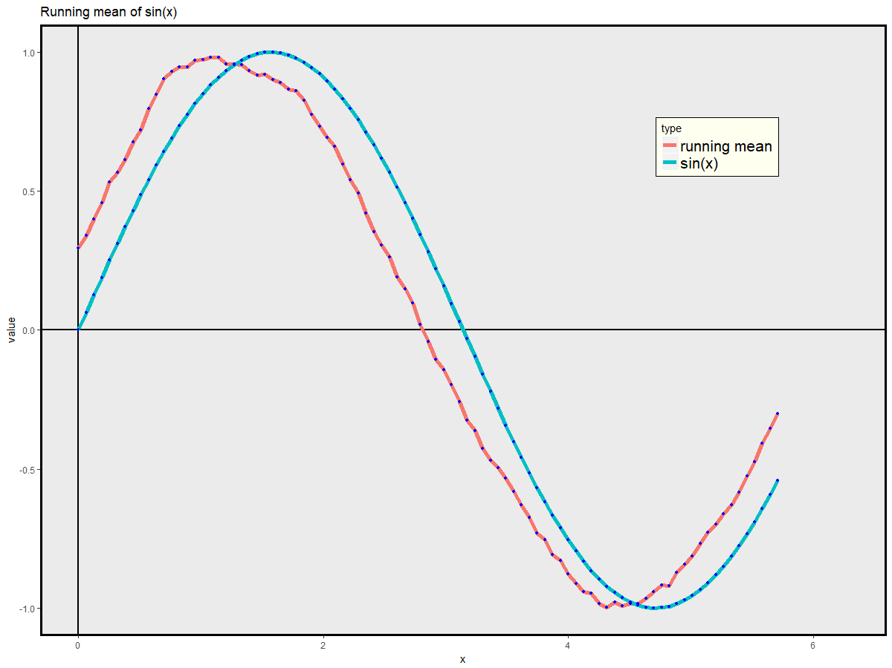

* 附錄 (R code)

Github : <https://github.com/CaoCharles/Statistical-Computing-and-Simulation-HW3>

R Markdown :